TABLE OF CONTENTS

1. Home ………………………………………………………………………….…………………………01
2. Registration …………………………………………………………………………….…………….02
3. Donate ………………………………………………………….……………………………………….03
4. Volunteer …………………………………………………….………………………………………..04
5. About Us …………………………………………………….…………………………………………05
6. Contact Us ………………………………………………….…………………………………………06

INTRODUCTION

Theresa Orphanage is a registered, non-governmental organization which has been serving the community of orphan children for the past thirty three years.

We provide education, food, shelter and medical assistance to our children. We strive hard to provide the better life for our kids. We have our branches in Karnataka, Andra Pradesh and in Tamil Nadu.

Our Vision - We look forward for a world where the children are given love and care they are entitled of. We anticipate a world where every child gets the rights to live with dignity!

Our Mission - We want to work more and more in order to provide shelter and care for more number orphan kids. We want to create the sense of awareness among the generation of this country so their kids don’t have to face what the kids at our Ashram do!

PROJECT TITLE

Theresa Orphanage

SOFTWARE USED

Languages used: HTML, CSS, JavaScript

Web browser: Chrome/Microsoft Edge

Operating System: Windows 10

COMPONENTS

**REGISTER**

**Description**: People who wants to donate to the organization must have to register themselves to the system.

System takes following data during registration:-

* Name
* Username
* Email
* Age
* Phone Number
* Password
* Confirm Password
* Address

Above registration forms should be validates as below:

* All field should contain values.
* Email ID should be given in correct form.
* Mobile number should be unique and should contain 10 digits

**DONATE**

**Description:** Donation page comprises of three options- food donate, clothes donate,

and fund transaction. The donors can voluntarily donate through the

app to the orphanages.The donors can select the orphanage which they

wish to donate in our website.

Donate page contains many necessary components and fields as below and user must have to fill them in order to donate to the organization.

* First name
* Last name
* Date of birth
* Phone number
* Donation fields like Books, Clothes, Food, Finance
* Bank Name
* IFSC code
* Account Number
* Validate it by click on submit

**VOLUNTEER**

**Description:** The orphanage program offers volunteers the opportunity to give love,

care, affection and attention to the kids who are in need. This volunteer

opportunity is full of life and is often viewed as life-changing experience.

Volunteer page contains many necessary components and fields like

they have to fill their fields like

● First name

●Last name

●DOB

●Email

●Gender

**ABOUT US**

**Description:** About us page gives the information about the Theresa Orphanage Site

It gives information about few components like

* Who we are
* Our Mission

**CONTACT**

**Description:** It gives certain information to the people to contact this orphanage to those who want to donate or to become volunteer or to register to our site.

This page contains some proper needed information like

l Address

l Phone number

l Location

l Landmark

l Email address

l Contacting information of organization

SYSTEM ARCHITECHTURE

Home

Fill in details

Register

User

Send Message

Fill details

Contact Us

About Us

Submit

Fill in details

Volunteer

Submit

Fill in details

Donate

Screenshots

HOME

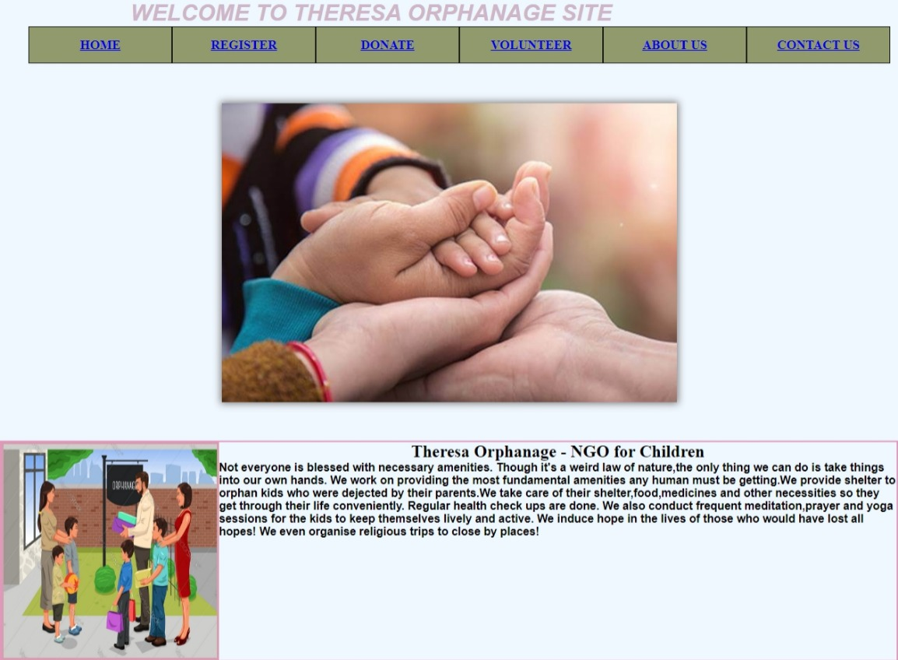

REGISTER

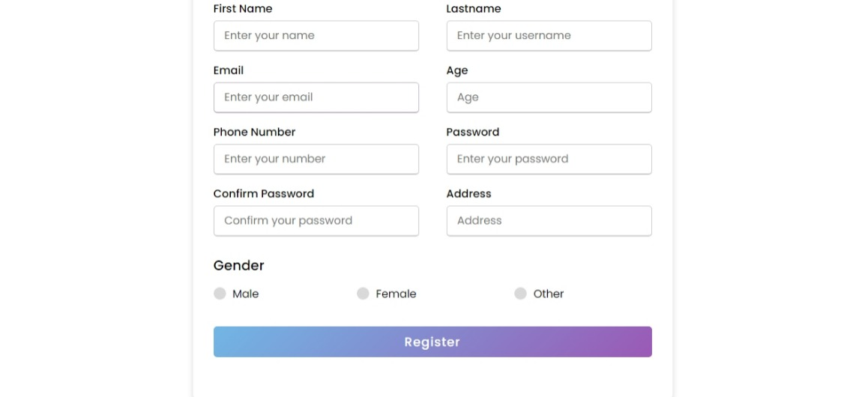

DONATE

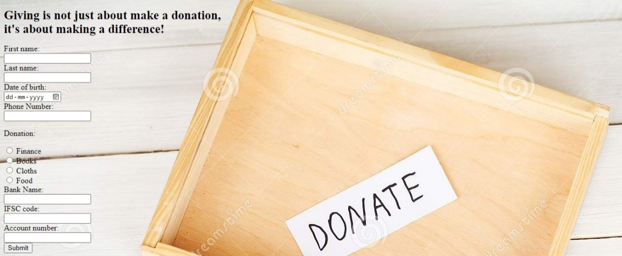

VOLUNTEER

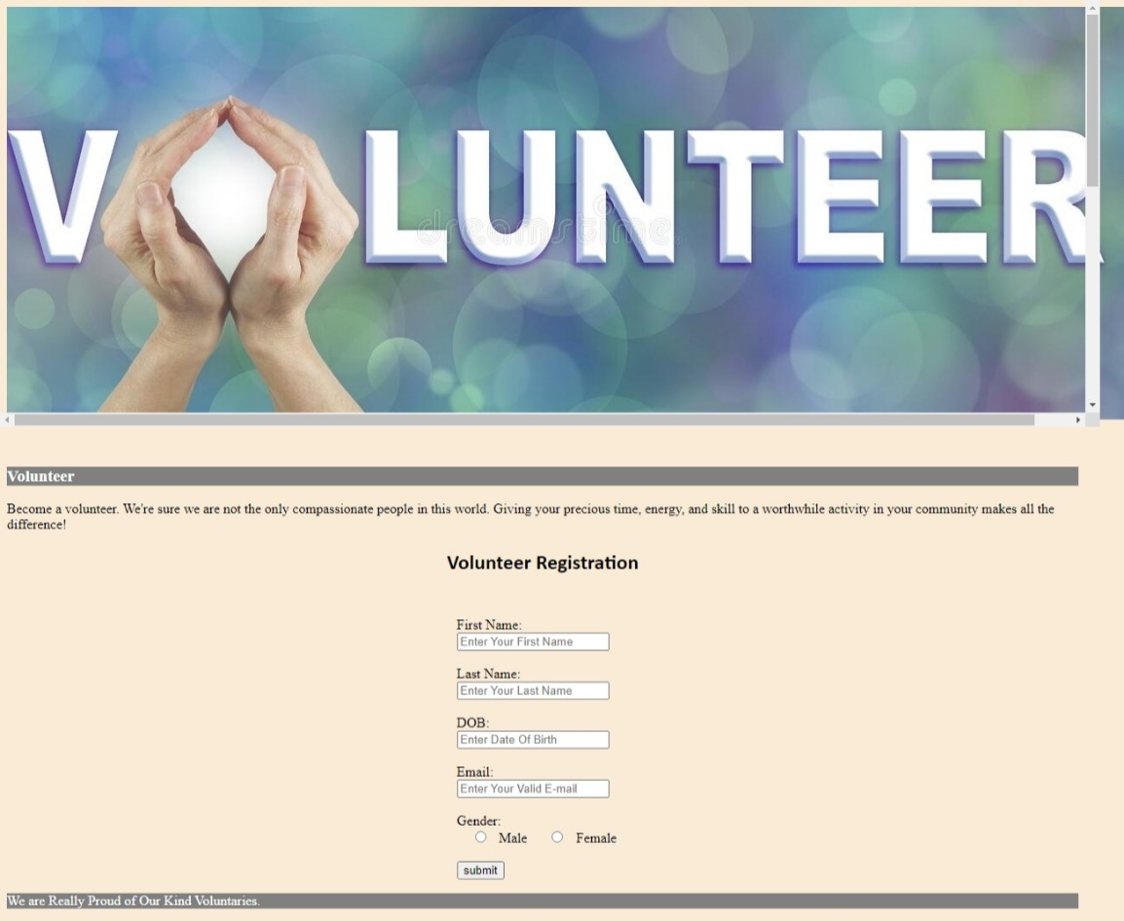

ABOUT US

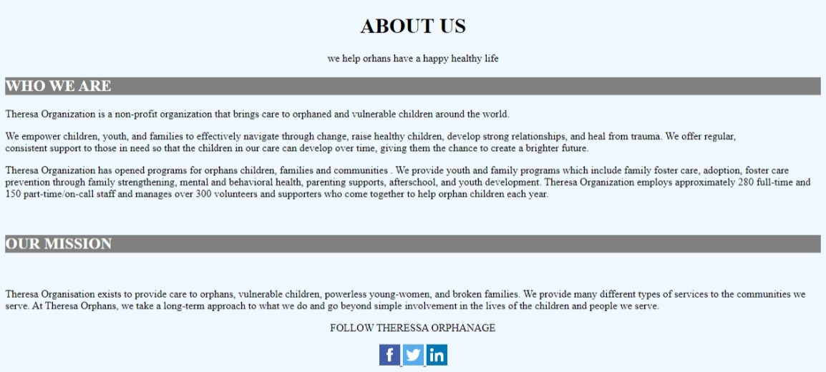

CONTACTUS